[Test Plan] Sauce Demo version 1.0

Document Status | [DRAFT] [REVIEWED] [FINAL]
Test Plan Creator | M Ridhwan K
Test Plan Reviewer | - Rafis  - Siti  - Reviewer_3

Introduction

Overview Feature to be tested
Eg:
The Test Plan has been created to communicate the test approach to team members. It includes the objectives, scope, schedule, risks and approach. This document will clearly identify what the test deliverables will be and what is deemed in and out of scope.
Eg:
This Test Plan is made to ensure that all features on the saucedemo.com website function properly and meet the criteria according to user needs.

Goals and Objective
Eg:
Test Case Tamer is a web-based Test Management tool used to create and store tests as well as the results of running those tests. This tool is a new product written with Ruby on Rails using a ‘mysql’ database. The test team is responsible for testing the product and ensuring it meets their needs. The test team is both the customer and the tester in this project.

Phase 1 of the project will deliver TCT (Test Case Tamer) with functionality to create and store manual tests. This will allow the test team to start transferring tests over to the new system. Must have functionality is considered more important than the delivery date in this project.

Eg:

The saucedemo.com website is a website that simulates a simple online store (e-commerce) that has features such as a login page, product list dashboard, shopping cart, and checkout. The stages of testing the features carried out by manual testing (Manual Test) are as follows:

- Testing the Login page features aims to ensure users do not experience problems when performing the login and logout process. The test scenario is to use a valid username, invalid, stable connection and unstable connection.
- Sort
- Sort price low to High
- Sort price high to low…
- Sort product name A to Z
- Sort product name Z to A
- Logout …

Test Item
List of test items (feature / product)

No | Feature | Test Item
#1 | Login | - Login with valid credentials  - Login with invalid credentials  - Login with user doesn’t exist
#2 | Sort | - Sort price High to Low
#3 | Logout | - Function logout work properly

In Scope Testing
List of in feature to be tested

No | Feature | Requirement / Design specifications
#1 | Login | 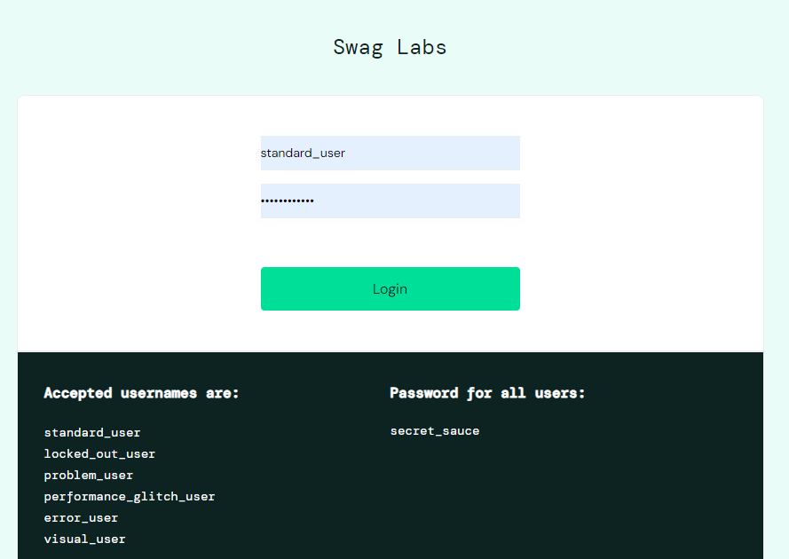
#2 | Sort

Out of Scope Testing
List the features of the software / product which will not be tested.

No | Feature | Reasons
#1 | Register | This testing phase will be focus to test login feature

Testing Approach
Summary of testing approach that will be implemented during testing phase

Eg:
The project is using an agile approach, with weekly iterations. At the end of each week the requirements identified for that iteration will be delivered to the team and will be tested.

Exploratory testing will play a large part of the testing as the team has never used this type of tool and will be learning as they go. Tests for planned functionality will be created and added to TCT as we get iterations of the product.

Eg:
The testing process uses Exploratory testing type because the tester does not know from the beginning the process of making the saucedemo.com website. So that the tester explores the website to test whether the website is suitable and can be used by users without any problems.

Test Environment
Information about testing environment that will be used during testing phase e.g URL, and version of App
- Website: https://www.saucedemo.com/
- Android version: v1.1.1
- iOS version: v1.2.0
- Env:Dev/Staging/Production
- Browser: Edge, Chrome, Firefox

Test Deliverables
- Test Plan (this document itself): [link]
- Test Case: [link]
- Test Script (if any): [link]
- Test data (if any): [link]
- Defect Report: [link]
- Test Report: [link]

Testing Timeline

No | Task | Estimation Time |  | Actual Time
 |  | Start Date | Finish Date | Start Date | Finish Date
#1 | Develop Test Planning | 3 Jan 2024 | 4 Jan 2024 | 3 Jan 2024 | 4 Jan 2024
#2 | Develop Test Case | 5 Jan 2024 | 5 Jan 2024
#3 | Test Case Review | 6 Jan 2024 | 6 Jan 2024
#4 | Execute Test | 7 Jan 2024 | 8 Jan 2024 | 10 Jan 2024 | 13 Jan 2024
#5 | Retest Bug | 9 Jan 2024 | 10 Jan 2025

References
List of related documents e.g PRD, Figma design, API Contract, Copy document etc

API Contact: [link],
Design: [Figma]

